**FOUNDATION BUILDER**

Foundation Builder program has been designed to lay a strong foundation of Science and Mathematics for the students of class IX to X. The classroom training is provided to the students which build strong reasoning and analytical skills in Mathematics and Science by supplementing and expanding the knowledge acquired in school. Conceptual clarity allows students to gain strength in the subject and generate interest and liking for the subject. Therefore, our students would have a dual advantage over other students in terms of their enhanced knowledge at the respective school exams as well as well-equipped in age-appropriate competitive exams.

**COMPETITIVE EXAMS**

# FOUNDATION BUILDER

Foundation Builder program has been designed to lay a strong foundation of Science and Mathematics for the students of class IX to X. The classroom training is provided to the students which build strong reasoning and analytical skills in Mathematics and Science by supplementing and expanding the knowledge acquired in school. Conceptual clarity allows students to gain strength in the subject and generate interest and liking for the subject. Therefore, our students would have a dual advantage over other students in terms of their enhanced knowledge at the respective school exams as well as well-equipped in age-appropriate competitive exams.

# COMPETITIVE EXAMS

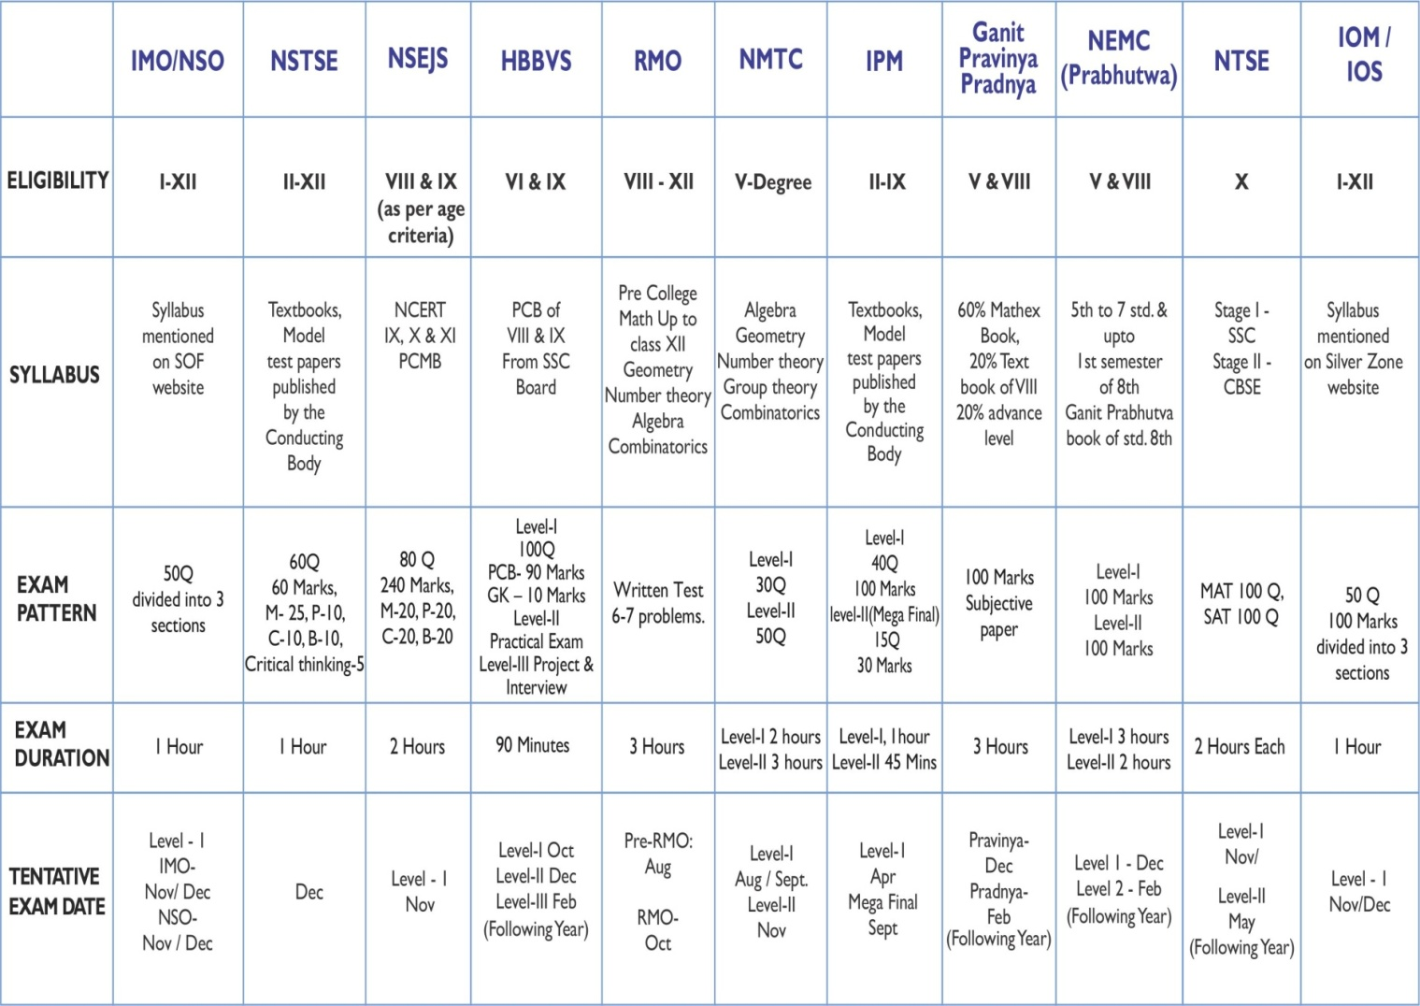

**COURSES**

* batch is for those students who due to some reason could not join Batch-1.

1. **For 9th Std**

**Batch -1**

**Batch -2**

2. **For 10th Std**

**For 10th std (Three Year Flagship Program)**

* This flagship course is for those students who want to get on with their JEE/Medical preparation as early as 10th std.
* Recommended for toppers and extremely hard-working students who want to have an edge over others to secure top ranks in JEE/NEET/Olympiads.
* ).
* Early beginners and top achievers make this batch.

**ENGINEERING**

A degree in Engineering can open many professional doors and guarantee the beginning of a stellar career. Engineering is a very broad field that offers dozens of specialization opportunities.

**SKILLS REQUIRED FOR ENGINEERING**

An aptitude for mathematics

Ability to solve conceptual problems

Drive and Determination

Ability to think logically

**ENTRANCE EXAM**

JEE Main – Joint Entrance Examination Main

JEE Advanced – Joint Entrance Examination Advance

BITSAT – Birla Institute of Technology & Science Admission Test

**COURSES WE OFFER**

1. **ZENITH PROGRAM (TWO YEAR JEE-ADVANCED + OLYMPIADS)**

          Students moving from class X to XI

* This course is designed to cover the depth and breadth of board syllabus as well as competitive examinations and build a strong fundamental base in Physics, Chemistry & Mathematics for sharpening their analytical skills and developing their problem-solving ability for competitive examinations.
* Regular Topic Wise Tests (TWTs) are conducted (Online/ Offline) to ensure that the students have fundamentally understood the topic well and the conceptual knowledge of the topic is developed.
* Major test with cumulative portion is taken periodically to give students a conceptual understanding of the difficulty level, time management, the diverse set of questions and patterns and also ranking at an All India level on JEE Main & Advanced.
* Online tests are given so that students get real-time exposure from the very beginning.
* All India Test Series (AITS) is a series of full-length tests conducted after course completion to give the student immense practice for the JEE Main/ Advanced and also to know their national-level performance and All India Rank across all AAYAAM centers.
* Regular feedback is taken from the students to identify actions to be taken to improve & enhance their performance.
* A detailed analysis report is given post every test.
* Our faculty is a team of highly experienced and reputed IIT-ians and top academicians from their respective fields who excel at competitive exam preparation.
* Duration of lectures 18 hours per week.
* Separate Olympiad batches are formed after course commencement and specific lectures for Physics / Chemistry / Biology / Astronomy and KVPY are conducted.

  2. **PREMIER PROGRAM (TWO YEAR JEE MAIN+ OLYMPIADS)**

      Students moving from class X to XI

* This course is designed to support the student for board syllabus as well as competitive examinations.
* Regular Topic Wise Tests (TWTs) are conducted (Online/ Offline) to ensure that the students have fundamentally understood the topic well and the conceptual knowledge of the topic is developed.
* Major test with cumulative portion is taken periodically to give students a real-time understanding of the difficulty level, time management
* Online tests are given so that students get real-time exposure from the very beginning.
* All India Test Series (AITS) is a series of full-length tests conducted after course completion to give the student immense practice for the JEE Main and also to know their national-level performance and All India Rank across all PACE centers.
* Regular feedback is taken from the students to identify actions to be taken to improve & enhance their performance.
* A detailed analysis report is given post every test.
* Our faculty is a team of highly experienced and reputed IIT-ians and top academicians from their respective fields who excel at competitive exam preparation.
* Duration of lectures 18 hours per week.

  3. **SUPPORT PROGRAM (TWO YEAR JEE MAIN + JEE ADVANCE)**

      Students moving from class X to XI

* This course is designed to cover the depth and breadth of competitive examinations.
* A team of highly experienced and reputed IIT-ians and top Academics from their respective fields, who excel at competitive exam preparation.
* All India Test Series (AITS) is a series of full-length tests conducted after course completion to give the student immense practice for the JEE Main/ Advanced and also to know their national-level performance and All India Rank across all AAYAAM centers.
* Regular feedback is taken from the students to identify actions to be taken to improve & enhance their performance.
* A detailed analysis report is given post every test.
* Our faculty is a team of highly experienced and reputed IIT-ians and top academicians from their respective fields who excel at competitive exam preparation.

  4. **ALL INDIA TEST SERIES (ONLINE)**

This Course is meant for those students who have studied the topics themselves and want to check their preparation level and compete with Top Rankers on All India basis for Competitive Exams. The students prepared for the test as scheduled provided them at the time of admission. Students are provided with a detailed analysis of the test. All India Test Series Course for JEE (Main & Advanced) for XII Students. The main objective is to provide constant practice which covers all the topics and the unit as per the syllabus.

**JEE Main:-** 10 online tests (Oct – Nov.)  
5 online tests (Mar-April)

**JEE Advanced:-** 10 online mock tests (March-May)  
10 online AITS (March-May)

(As per new JEE Main Pattern)

5. **CRASH COURSE**

This Program helps students to cover important topics systematically and simultaneously trains them to tackle the entrance examination level problems in such a way that it helps them to improve their expected All India Rank.

The entire syllabus is covered in the short period by the best professors and it is discussed from the entrance exam point of view. To give the students the feel of the actual exams, they are also provided with All India Test Series through which they get to know their All India Rank across the PACE centers.

1) This Course is designed to cover the entire syllabus of JEE Main and Advanced in a short period.  
2) Batch Schedule: 4 days a week.

7. **DISTANCE LEARNING PROGRAM ( JEE-ADVANCED / JEE MAIN)**

Students who could not join our regular classroom program can enroll in our distance learning program. It doesn’t matter where you live PACE facilitates students to take classes from any sphere of the Country. This program offers students the flexibility to use time according to their requirements.

1) This course is for all students who due to some reason could not join the regular classes.  
2) Our study material along with our Topic wise test & All India Test Series will be delivered to the students.  
3) Access of online portal will be provided by AAYAAM.

8. **Correspondence Course**

The material will be provided with an online test series.

**MEDICAL**

Study of medicine builds a career that offers opportunities to improve people’s health and save lives. Your zeal to serve people, critical thinking and working diligently under pressure can present a plethora of career options for you.

**SKILLS REQUIRED FOR MEDICAL**

Attention to detail

Concern for people

Rational approach

Determination

Patience

An enquiring mind

**ENTRANCE EXAM**

AIIMS – All India Institute of Medical Sciences

NEET – The National Eligibility cum Entrance Test

JIPMER – The Jawaharlal Institute of Postgraduate Medical Education & Research

**COURSES WE OFFER**

1. **ZENITH PROGRAM (NEET + AIIMS + JIPMER + OLYMPIADS)**

          Students moving from class X to XI

* This course is designed to make the students fundamentally strong in Physics, Chemistry & Biology sharpening their analytical skills and developing their problem-solving ability for competitive examinations.
* This course also covers the depth and breadth of board syllabus.
* Regular Topic Wise Tests (TWTs) are conducted (Online/ Offline) to ensure that the students have fundamentally understood the topic well and the conceptual knowledge of the topic is developed.
* Major test with cumulative portion is taken periodically to give students a real-time understanding of the difficulty level, time management, the diverse set of questions and patterns and also ranking at an All India level on NEET/AIIMS/JIPMER.
* Online tests are given so that students get real-time exposure to the new pattern of NEET testing from the beginning.
* All India Test Series (AITS) is a series of full-length tests conducted after course completion to give the student immense practice for the NEET/AIIMS/JIPMER and also to know their national-level performance and All India Rank across all PACE centers.
* Regular feedback is taken from the students to identify actions to be taken to improve & enhance their performance.
* A detailed analysis report is given post every test.
* Our faculty is a team of highly experienced and reputed IIT-ians and top academicians from their respective fields who excel at competitive exam preparation.
* A detailed analysis report is given post every test.

  2. **TWO YEAR SUPPORT PROGRAM (NEET + AIIMS + JIPMER)**

      Students moving from class X to XI

* This course is designed to cover the depth and breadth of competitive examinations preparation.
* Practice test papers that help in the preparation of competitive exams are also provided.
* All India Test Series (AITS) is a series of full-length tests conducted after course completion to give the student immense practice for the NEET/AIIMS/JIPMER and also to know their national-level performance and All India Rank across all PACE centers.
* Regular feedback is taken from the students to identify actions to be taken to improve & enhance their performance.
* A detailed analysis report is given post every test.
* Our faculty is a team of highly experienced doctorates and top academicians from their respective fields who excel at competitive exam preparation.

  3. **REPEATERS (NEET)**

      Students moving from class X to XI

In this course, we impart knowledge that helps students address weak areas of his/her previous year’s preparation. The program covers the entire syllabus of NEET/AIIMS/JIPMER.

* For class, XII passed students  
  In this course we impart the right knowledge to students, highlighting the weak areas of his/her previous preparation
* This program covers the entire syllabus of NEET, AIIMS & JIPMER.

5. **ALL INDIA TEST SERIES (ONLINE/OFFLINE)**

This Course is meant for those students who have studied the topics themselves and want to check their preparation level and compete with Top Rankers on All India basis for Competitive Exams. The students prepared for the test as scheduled provided them at the time of admission. Students are provided with a detailed analysis of the test.

10 online NEET test (Oct-Jan)  
10 online NEET test after board exam till NEET exam (in between March-May)  
5 AIIMS online test after NEET exam  
(As per new NEET pattern)

7. **Correspondence Course**

The material will be provided with an online test series.

Students moving from class X to XI

**ENGINEERING- JEE MAIN, JEE ADVANCED, CLASS XIth ,XIIth & DROPPER (CRASH COURSE)**

**MEDICAL – NEET CLASS XIth ,XIIth & DROPPER (CRASH COURSE)**

**FOUNDATION – CLASS – IXth ,Xth**